Developing Software

Put these stages of the software development process in order:
5
The customer checks and approves the final version
Speak with the people who will use the new software and analyse how they will use it.
1
Plan the project, write the specifications and prepare instructions for the programmers.
2
Test and debug the code
4
Write the code
3

Reading:
Read the interview from Computer World, an online magazine, in which Jess Wong, a systems analyst, talks about her job. Which of the stages above does she mention?

Interface specification process client pop-up developers flow charts changes step

CW: So, Jess, could you tell us about the requirements analysis prosess?
JW: First, we talk to the client to find out who the users will be. Then we interview as many users as possible. This can be difficult because we have to look at every step in the process in a lot of detail.
CW: And what’s the next step ?
JW: Next, we make the specification document. This shows everything that the program does. We have to write down what every button does, what will appear on every pop-up enu, and so on.
CW: Is this where you draw flow charts ?
JW: Yes, and the user Interface.
CW: And does the client check the specification document?
JW: Yes. We need the client to be happy with it. We usually have to make some changes at this stage but it is usually quite quick. Then we give the project to the developers so they can start programming.

Comprehension:
- Why does Jess talk to the client at the beginning of the process?
- Why are the interviews sometimes difficult?
- What is in the specification document besides writing?
- Why does the analyst want the client to check the specification document?

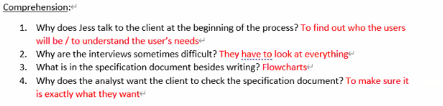

Vocabulary: Match these words with their definitions

Approve ( C)  Analyse ( B)  Debug ( E)  Detail (A)  Interview ( Dx) | All the separate features and pieces of information about something  Think about something very carefully; step-by-step  Officially say you are happy with something  Ask someone questions to find out information  Find problems in a computer program and fix them

Listening:
Listen to a systems analyst talking to a worker. He is preparing specifications for a pizza shop website to take orders online. Which stage in the process is he at?

Listen again and complete 1-4 in this flow chart
- Ask which type of standard pizza. 3
- Ask which toppings. 2
- Customer wants standard pizza? 1
- Write order on order sheet. 4

Listen again and complete 5-8
- Ask for delivery address. 6
- Customer wants another pizza? 5
- Calculate delivery time. 7
- Tell customer deliver time. 8
Label the flowchart. Which one doesn’t appear on the flow chart?
- Terminal symbol – start/End (circle, rectangle with rounded corners)
- Input/Output – Paeallelogram
- Process – Rectangle
- Initialization/Preparation
- Decision – Diamond
-----------------------------------------------------------------------------------------------------------------------------------

Make the flowchart for the following virus checking process:

First, the program should ask the user if they want to run scan the whole computer or target certain drives/folders.
If the user chooses a targeted scan, they need to select which drives/folders they want to scan.
Next, the scan should start
Once the scan is finished, any files containing viruses are automatically deleted.
At the end of the process, the AV program should close.

Programming Code

Listening:
Listen to the programmers talking about this code which controls a robot by using a mobile phone. Number the variables in the order they are explained. G game, g turn, key press

Listen again and complete these sentences:
- If g_Move has the value 0, the robot doesn’t move
- If g_Turn has the value 0, the robot doesn’t turn
- If you press ‘x’ on the phone, key_Press has the value ‘x’
Listen to the rest of the conversation and label these illustrations with the correct keys
F d a s
Complete the flow chart:

Language
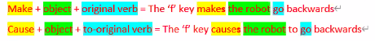
What do the following do? Write sentences using the pattern above:
the mouse makes the cursor move / causes the cursors to move
clicking the ‘maximise’ button ________________________________________________
clicking the ‘x’ button ________________________________________________
a double click on the file icon ________________________________________________
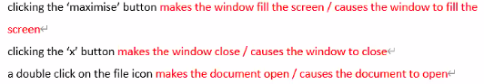

Presentations
Think of three pieces of advice about giving presentations:

Plan a structure (intro-body-conclusion)

Don’t read a script / Don’t memorise a script / Practice

Speak clearly / don’t mumble / don’t speak too fast
Eye contact
Gestures / Don’t fidget (make unnecessary movemonts)

Read about Double Jam, a company that needs advice about a new website. Read their profile and the two options below and decide which you think is better:
Listening:
Listen to an IT consultant giving a presentation and answer the questions
- What is the presentation about?
- What are her recommendations?
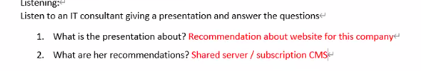
Listen again and complete this table with the English expressions the presenter uses:
Part | Expressions in presentation | Your ideas
Introduction | first, I’ll give…
Body
Conclusion
